Day 1 – End-to-End Setup & Development Summary
Goal for Day 1
Build the integration workflow:
Blob Added in ADLS → Event Grid → Azure Function → Service Bus Queue
Successfully implemented, tested, and verified the entire flow.

1. Created Required Azure Resources
✔1.1 Storage Account (ADLS Gen2)
- Name: banksourcedata
- Role: Source location where folders/files (atm, customers, upi) arrive.
- Enabled hierarchical namespace (ADLS Gen2).
- Created container: raw
✔ 1.2 Function App
- Name: Bank-Func-app
- Runtime: Python
- Hosting: Consumption plan
- Purpose: To receive Event Grid events and push blob metadata to Service Bus.
✔ 1.3 Service Bus Namespace
- Name: Service-Bus-Bank
- Pricing: Basic Tier
- Purpose: Queue messages from Function App.
✔ 1.4 Service Bus Queue
- Name: queue_ingestion
- Role: Temporary buffer for blob processing events.

2. Configure Event Subscriptions (Event Grid)
✔ 2.1 Enable Event Grid on Storage Account
- Navigated to: Storage Account → Events
- Created a System Topic automatically:
  - Name: Event-Trigger-New-File-Topic
  - Topic Type: Microsoft.Storage.StorageAccounts
✔ 2.2 Event Subscription
- Name: Event-Trigger-New-File
- Trigger Types:
  - BlobCreated
  - BlobDeleted
- Endpoint Type: Azure Function
- Selected function: EgBlobToQueue
This ensures that whenever a new blob is uploaded, Event Grid immediately triggers our Function App.

3. Built the EventGrid-Triggered Azure Function
✔ 3.1 Code in __init__.py
import json
import logging
import azure.functions as func
from azure.servicebus import ServiceBusClient, ServiceBusMessage
import os

def main(event: func.EventGridEvent):

logging.info("Event Grid Trigger Fired for New File Upload")

event_data = event.get_json()
url = event_data["url"] # file URL
file_name = url.split("/")[-1] # extract filename

logging.info(f"File Uploaded: {file_name}")

# Basic Validation
if not file_name.endswith(".csv"):
logging.error("Invalid file format. Only CSV allowed.")
return

# Detect source type based on filename
source_type = ""
if "atm" in file_name.lower():
source_type = "ATM"
elif "upi" in file_name.lower():
source_type = "UPI"
elif "customer" in file_name.lower():
source_type = "CUSTOMER"
else:
source_type = "UNKNOWN"

# Prepare message body
message_body = {
"file_url": url,
"file_name": file_name,
"source_type": source_type
}

logging.info(f"Sending message to Service Bus: {message_body}")

# Send to Service Bus Queue
sb_client = ServiceBusClient.from_connection_string(
conn_str=os.environ["SERVICE_BUS_CONNECTION_STRING"]
)

queue_name = os.environ["SERVICE_BUS_QUEUE_NAME"]

with sb_client:
sender = sb_client.get_queue_sender(queue_name=queue_name)
with sender:
sb_message = ServiceBusMessage(json.dumps(message_body))
sender.send_messages(sb_message)

logging.info("Message sent to Service Bus Queue successfully.")

The function performs exactly THREE tasks:
- Receive Event Grid event
- Extract blob URL
- Push message to file-queue

4. Configured Application Settings
Inside func-app-bank → Configuration:
Added:
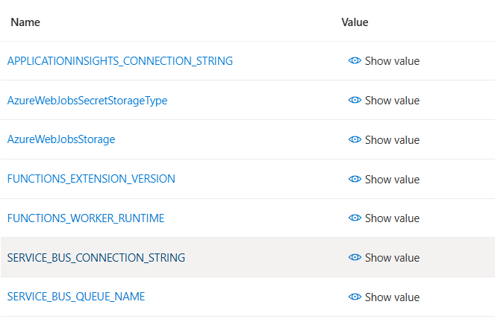
5. Tested End-to-End Workflow
Step 1: Uploaded sample files in ADLS
Locations tested:
- /raw/atm
- /raw/customers
- /raw/upi
Step 2: Verified Events
In Storage → Events:
- Event Grid showed Published, Delivered, Matched events
- Successful delivery count increased
Step 3: Function App Logs
Under Bank-Func-app→ Logs:
- Confirmed Function triggered multiple times
- No errors
- Host running fine
Step 4: Service Bus Verification
In Service-Bus-Bank→ queue_ingestion:
- Successful Requests count increased
- Message Count = count increased
- No dead-letter
- Queue successfully received + auto-cleared messages
All parts worked correctly.

6. Final Architecture Validated (Day 1 Output)
ADLS Gen2 → Event Grid → Function App → Service Bus Queue
Everything is connected and functional.

